**DBMS Project**

**“Key Milestone 2”**

**Spring 2025**

**CSE 404L – Database Management Systems Lab**

**SUBMITTED BY:** Hoorish Ahmad

Afreen Nasrullah

Sidrah Ishtiaq

**REGISTRAION NUMBER:** 22PWCSE2198

22PWCSE2195

22PWCSE2159

**BATCH:** 24

**CLASS SECTION:** B

**SUBMITTED TO:** Engr. Sumayyea Salahuddin

*Department of Computer Systems Engineering*

University of Engineering and Technology, Peshawar

**Relational Schema:**

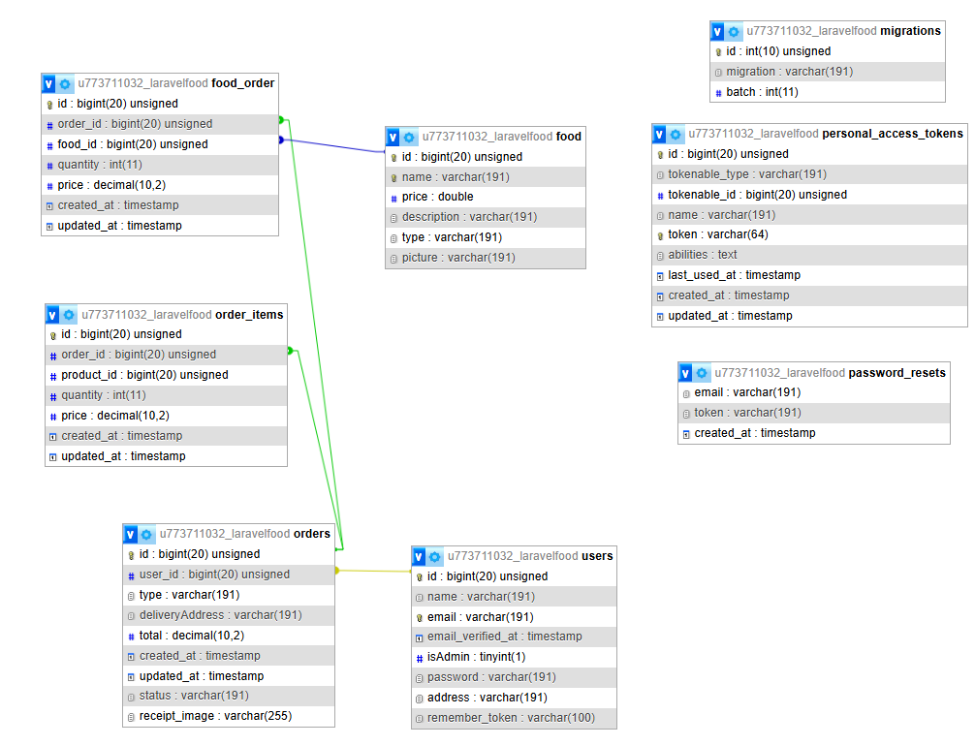

**Normalization:**

**USERS Table:**

**1NF:** Remove repeating groups

Already in 1NF — no multivalued attributes.

**2NF:** Remove partial dependencies

Already in 2NF — id is the primary key; all non-key columns fully depend on it.

**3NF:** Remove transitive dependencies

Still valid — no non-key column depends on another non-key column.

Final users table (3NF) remains unchanged:

|  |  |  |  |
| --- | --- | --- | --- |
| Column Name | Data Type | Key | Notes |
| id | BIGINT | PK | Auto-increment |
| name | VARCHAR |  |  |
| email | VARCHAR | UNIQUE | Must be unique |
| email_verified_at | TIMESTAMP |  | Nullable |
| isAdmin | BOOLEAN |  | Default: false |
| password | VARCHAR |  |  |
| address | VARCHAR |  |  |
| remember_token | VARCHAR |  | Nullable |

**FOOD Table:**

**1NF:** No repeating groups

Already in 1NF

**2NF:** All columns fully depend on PK (id)

Yes — name, price, etc. depend on id

**3NF:** No transitive dependencies

No field is derived from another non-key (e.g., type is not derived from description)

Final food table (3NF):

|  |  |  |  |
| --- | --- | --- | --- |
| Column Name | Data Type | Key | Notes |
| id | BIGINT | PK | Auto-increment |
| name | VARCHAR | UNIQUE | Must be unique |
| price | FLOAT |  |  |
| description | VARCHAR |  |  |
| type | VARCHAR |  | e.g., FastFood, Beverage |
| picture | VARCHAR |  | Path to image |

**ORDER Table:**

**1NF:** No repeating groups

Already in 1NF

**2NF:** Fully functional dependency on PK

All fields depend only on id

**3NF:** No transitive dependency

We assume type and deliveryAddress are atomic and not derived from other fields.

Final order table (3NF):

|  |  |  |  |
| --- | --- | --- | --- |
| Column Name | Data Type | Key | Notes |
| id | BIGINT | PK | Auto-increment |
| user_id | BIGINT | FK | References users(id) |
| date | DATETIME |  | Order time |
| type | VARCHAR |  | 'online', 'pickup', etc. |
| deliveryAddress | VARCHAR |  | Nullable for pickup orders |

**FOOD_ORDER Table:**

**1NF:** Split rows per food item

|  |  |  |
| --- | --- | --- |
| order_id | food_id | quantity |
| 1 | 1 | 1 |
| 1 | 2 | 2 |

**2NF:** Composite PK (order_id, food_id)

quantity depends on the full PK, not just part of it

**3NF:** No transitive dependencies

All columns depend only on the whole PK

Final food_order table (3NF):

|  |  |  |  |
| --- | --- | --- | --- |
| Column Name | Data Type | Key | Notes |
| order_id | BIGINT | PK, FK | References order(id) |
| food_id | BIGINT | PK, FK | References food(id) |
| quantity | INTEGER |  | Quantity of that food in the order |

**PASSWORD_RESETS Table:**

Simple table, no normalization issues and Composite candidate key:

email + token

Final password_resets table (3NF):

|  |  |  |  |
| --- | --- | --- | --- |
| Column Name | Data Type | Key | Notes |
| email | VARCHAR | INDEX | Indexed for fast lookup |
| token | VARCHAR |  | Reset token |
| created_at | TIMESTAMP |  | Nullable timestamp |

**PERSONAL_ACCESS_TOKENS Table:**

Already normalized:

* All attributes depend on id
* No repeating groups or transitive dependencies

Final personal_access_tokens table (3NF):

|  |  |  |  |
| --- | --- | --- | --- |
| Column Name | Data Type | Key | Notes |
| id | BIGINT | PK | Auto-increment |
| tokenable_type | STRING |  | Model type (e.g., User) |
| tokenable_id | BIGINT |  | ID of the related model |
| name | STRING |  | Token name |
| token | STRING(64) | UNIQUE | Unique access token |
| abilities | TEXT |  | Nullable |
| last_used_at | TIMESTAMP |  | Nullable |
| created_at | TIMESTAMP |  |  |
| updated_at | TIMESTAMP |  |  |

**References:**

* [www.chatgpt.com](http://www.chatgpt.com) (help in finding the normalization)
* [www.gemini.com](http://www.gemini.com) (understanding relational schema)